SIMATS ENGINEERING
CO4 - ASSESSMENT TOOL 3
Article Review
COURSE NAME: Deep Learning COURSE CODE: MLA0408

COURSE OUTCOME COVERED
CO 4: Students will be able to analyze and evaluate advanced deep learning techniques and architectures, interpret research findings, and apply appropriate models to real-world problems. They will be able to critically review research articles, compare methodologies, and justify suitable deep learning solutions. (BL-6)
Assessment Tool Weightage: 30%
QUESTIONS:
Q1. Article Identification and Summary
Select a recent peer-reviewed research article related to Deep Learning, such as CNNs, Transfer Learning, ResNet, DenseNet, RNNs, LSTM, Autoencoders, or other advanced architectures. Provide the article title, authors, publication venue, year, and research objective. Summarize the main problem addressed, proposed approach, and key findings in your own words.
Q2. Problem Statement and Motivation
Explain the real-world problem addressed by the selected article and analyze why the problem requires a deep learning solution. Identify the limitations of existing approaches discussed by the authors and explain the motivation for the proposed method.
Q3. Methodology and Architecture Review
Critically review the methodology used in the article. Describe the dataset, preprocessing, model architecture, important layers or components, training strategy, and evaluation metrics. Illustrate the proposed architecture or workflow and explain the role of its major components.
Q4. Results, Comparison and Critical Analysis
Analyze the experimental results reported in the article. Compare the proposed method with the baseline or existing methods using the reported performance measures. Discuss the strengths, limitations, computational considerations, and validity of the results. Identify at least two possible improvements or future research directions.

Q5. Application and Personal Evaluation
Explain how the reviewed deep learning method can be applied to a practical industry problem. Propose a suitable implementation or extension and justify your choices. Conclude the review with your overall evaluation of the article, including its contribution, practical relevance, and scope for future work.
Article Review Submission Guidelines
- Choose one recent and relevant peer-reviewed research article in Deep Learning.
- Attach or provide the complete citation/reference of the selected article.
- The review must be written in the student's own words and should demonstrate critical analysis.
- Include architecture diagrams, tables, graphs, or screenshots where they improve explanation.
- Use appropriate academic referencing and avoid plagiarism.
- Recommended review length: 4–6 pages, excluding the reference page.
Code of Conduct:
I vemula saiteja 192425083(Name / Reg No) certify that this submission is my original work and that I have adhered to the guidelines specified for this assessment. I understand that any violation of academic integrity rules will result in disciplinary action.
Signature of the student:

RUBRICS FOR CALCULATION
Criteria | Weightage | Level 4 – Exemplary | Level 3 – Proficient | Level 2 – Developing | Level 1 – Beginning
Article Understanding & Summary | 20% | Comprehensive and accurate understanding of the article, problem, objectives, and contributions. | Good understanding with minor omissions or inaccuracies. | Basic understanding; important details are missing. | Poor understanding or significant misinterpretation.
Critical Review of Methodology | 25% | Thoroughly evaluates methodology, architecture, datasets, training, and evaluation choices. | Appropriate analysis with minor gaps. | Limited analysis with several unexplained aspects. | Little or no meaningful analysis of methodology.
Analysis of Results | 20% | Accurately interprets results, comparisons, metrics, strengths, and limitations. | Good interpretation with reasonable comparison. | Basic interpretation with limited comparison. | Incorrect, unsupported, or missing interpretation.
Application & Proposed Improvements | 20% | Practical, innovative application with well-justified improvements and future directions. | Relevant application and feasible improvements. | Basic application with limited justification. | Unclear, impractical, or unsupported proposal.
Presentation & Referencing | 15% | Well-organized, professional presentation with clear diagrams and correct academic referencing. | Clear presentation with minor formatting or referencing issues. | Adequate presentation with inconsistent formatting/referencing. | Poor organization, unclear presentation, or inadequate referencing.

Suggested Article Review Structure
1. Article Citation
2. Abstract / Executive Summary
3. Research Problem and Motivation
4. Methodology and Deep Learning Architecture
5. Dataset and Experimental Setup
6. Results and Comparative Analysis
7. Strengths and Limitations
8. Proposed Improvements / Future Scope
9. Practical Industry Application
10. Conclusion and References

An improved transformer based traffic flow prediction model
Authors: Shipeng Liu and Xingjian Wang
Journal: Scientific Reports
Year: 2025
Volume: 15
Article number: 8284
DOI: 10.1038/s41598-025-92425-7
Official Scientific Reports article

Article Review: An Improved Transformer Based Traffic Flow Prediction Model

1. Article Citation

1.1 Article Details
The selected research article is titled “An improved transformer based traffic flow prediction model.” It was written by Shipeng Liu and Xingjian Wang and published in Scientific Reports in 2025. The article focuses on using an improved Transformer architecture for traffic-flow prediction in intelligent transportation systems.

1.2 Complete Citation
Liu, S., & Wang, X. (2025). An improved transformer based traffic flow prediction model. Scientific Reports, 15, 8284. https://doi.org/10.1038/s41598-025-92425-7.
Official Research Article

2. Abstract / Executive Summary

2.1 Research Background
Traffic-flow prediction is an important application of deep learning in intelligent transportation systems. Modern cities contain large numbers of vehicles, and unexpected traffic congestion can result in increased travel time, fuel consumption, and pollution. Accurate prediction of future traffic conditions can help transportation authorities manage roads and reduce congestion.

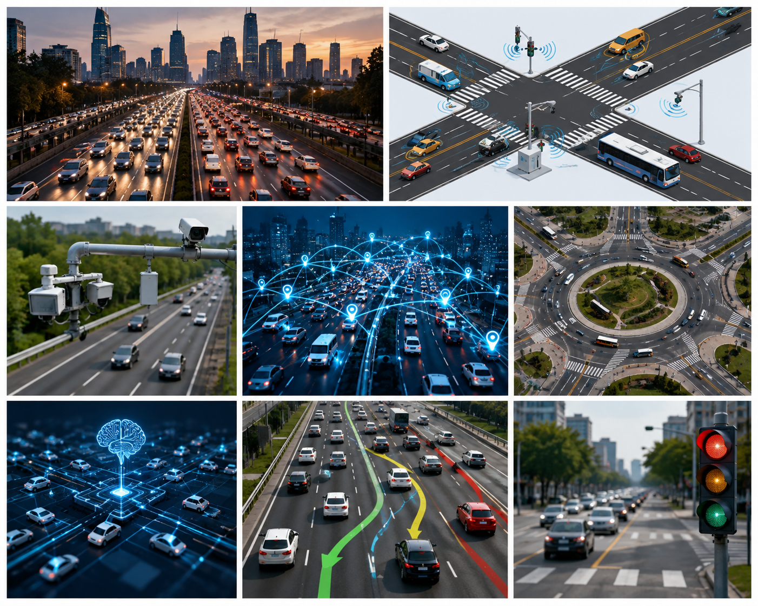

2.2 Proposed Solution
The authors propose an improved Transformer model called IEEAFormer. The model is designed to capture both temporal and spatial relationships in traffic data. It improves the traditional Transformer by introducing implicit-information embedding, temporal-environment-aware attention, and separate mechanisms for short-range and long-range spatial dependencies.

2.3 Main Findings
The proposed model is evaluated on four real-world traffic datasets: PEMS03, PEMS04, PEMS07, and PEMS08. The experimental results show that the proposed method performs better than many existing traffic-prediction models. The results demonstrate that Transformer-based architectures can effectively learn complex traffic patterns when both spatial and temporal information are considered.

3. Research Problem and Motivation

3.1 Real-World Problem
The main problem addressed by the article is the prediction of future traffic flow. Traffic patterns are affected by many factors, and the relationship between traffic observations is not simply linear. Traffic at one road location may influence another location, while traffic at the same location can change significantly over time.

3.2 Limitations of Existing Methods

Traditional statistical methods are often unable to capture the complex nonlinear relationships present in modern traffic data. CNN-based methods can extract local patterns but may not represent irregular road networks effectively. RNN-based models can process sequential information, but they can have difficulty learning long-term dependencies.Transformer models overcome some of these problems through attention mechanisms. However, conventional Transformer-based traffic models may not fully capture the hidden information and complex spatial relationships present in traffic networks.

3.3 Motivation for the Proposed Model
The authors were motivated to create a model that can understand traffic from both temporal and spatial perspectives. IEEAFormer attempts to identify how traffic changes over time, how nearby locations influence one another, and how distant locations may have similar traffic patterns.

4. Methodology and Deep Learning Architecture

4.1 Overall Methodology
The proposed system takes historical traffic-flow data as input and processes it through several deep learning components. First, the input data is converted into useful feature representations through an embedding process. The resulting information is then passed through Transformer-based temporal and spatial attention mechanisms.

4.2 Implicit-Information Embedding
The embedding component attempts to capture additional information hidden within the traffic data. The model also uses graph-based information to represent relationships between different traffic sensors. This helps the network understand that traffic sensors are not independent and that their locations are connected through a road network.

4.3 Temporal Attention
The temporal component uses a Temporal-Environment-Aware Self-Attention mechanism. It considers the surrounding temporal information before calculating attention. This allows the model to distinguish between traffic values that may appear numerically similar but occur in very different temporal situations.

4.4 Spatial Attention
The spatial component contains separate mechanisms for short-range and long-range spatial relationships. Short-range attention focuses on nearby road locations that directly influence each other. Long-range attention identifies locations that may be geographically distant but exhibit similar traffic patterns.

4.5 Output Layer
After extracting temporal and spatial features, the model combines the information and passes it through fully connected layers. The final output represents predicted traffic flow for future time steps.
4.6 Architecture Diagram
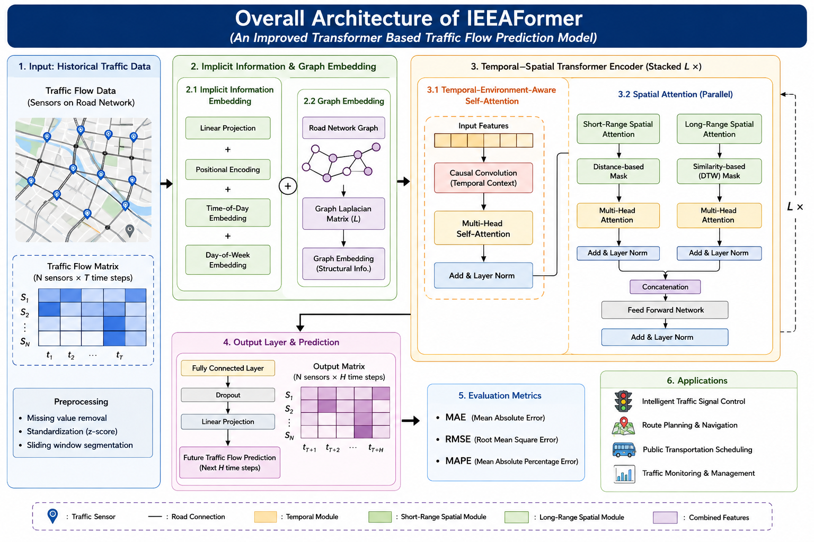

5.1 Dataset
The researchers use four real-world traffic datasets called PEMS03, PEMS04, PEMS07, and PEMS08. These datasets contain traffic-flow measurements collected from sensors installed at different road locations.

5.2 Data Collection
The traffic measurements are recorded at five-minute intervals. This provides a sequence of observations that can be used to understand how traffic changes over time.

5.3 Data Preprocessing
The researchers preprocess the traffic data before providing it to the model. Missing values are removed, and the data is standardized using its mean and standard deviation. The datasets are divided into training, validation, and testing sets.

5.4 Training Configuration
The model is implemented using PyTorch and trained using an NVIDIA GeForce RTX 2080 Ti GPU. The model uses multiple Transformer encoder layers and attention heads. The Adam optimizer is used during training, and early stopping is applied to avoid unnecessary training.

5.5 Evaluation Metrics
The performance is evaluated using MAE, RMSE, and MAPE. MAE measures the average absolute prediction error, RMSE gives greater importance to large errors, and MAPE represents the prediction error as a percentage.

6. Results and Comparative Analysis

6.1 Comparison with Existing Models
The authors compare IEEAFormer with several existing approaches, including traditional traffic-prediction methods, graph neural networks, recurrent models, and other Transformer-based models.

6.2 Performance on PEMS03
On the PEMS03 dataset, IEEAFormer achieves an MAE of approximately 15.00, RMSE of approximately 25.37, and MAPE of approximately 15.17%. These results demonstrate that the proposed model can effectively learn traffic patterns.

6.3 Performance on PEMS04
On PEMS04, the model achieves approximately 18.22 MAE, 30.31 RMSE, and 11.99% MAPE. These results indicate good prediction performance on another traffic network.

6.4 Performance on PEMS07
For PEMS07, the model achieves approximately 19.11 MAE, 32.60 RMSE, and 8.01% MAPE. The relatively low MAPE indicates good prediction accuracy compared with many baseline models.

6.5 Performance on PEMS08
On PEMS08, IEEAFormer achieves approximately 13.49 MAE, 23.20 RMSE, and 8.89% MAPE. The results are slightly better than the reported PDFormer results on this dataset, demonstrating the benefit of the proposed architectural improvements.

6.6 Overall Analysis
The results indicate that combining temporal and spatial attention improves traffic prediction. The ablation experiments also show that removing individual components such as implicit-information embedding or spatial attention reduces performance. Therefore, the improvements are not simply due to using a Transformer but are related to the specific design of IEEAFormer.

7. Strengths and Limitations

7.1 Strengths
The major strength of this research is that it treats traffic prediction as a spatio-temporal problem. Instead of considering only previous traffic values, the model also considers relationships between different road locations.
Another strength is the use of separate short-range and long-range spatial attention. This allows the model to understand both nearby road interactions and distant locations with similar traffic patterns.
The research also provides extensive comparisons using four real-world datasets. This makes the experimental evaluation stronger than testing the model on only one dataset.

7.2 Limitations
One limitation is the computational complexity of the attention mechanisms. When a city has thousands of traffic sensors, calculating spatial relationships between many locations can require significant computational resources.Another limitation is that traffic-flow prediction may be affected by external factors such as accidents, weather, road construction, festivals, and public events. Historical traffic data alone may not always provide enough information to predict sudden changes.

8. Proposed Improvements / Future Scope

8.1 Integration of Weather Data
The model could be improved by including weather information such as rainfall, temperature, visibility, and wind speed. Weather conditions can significantly influence traffic behavior.

8.2 Accident and Event Information

Accident reports, road construction information, public events, and holiday schedules could also be added. This would allow the model to respond better to sudden changes in traffic conditions.

8.3 Lightweight Model
The model could be compressed using pruning, quantization, or knowledge distillation. This would reduce computational requirements and make real-time deployment easier.

8.4 Real-Time Smart-City System

The model could be connected directly to traffic sensors and cameras so that it continuously receives new information and updates traffic predictions.

9. Practical Industry Application

9.1 Smart Traffic Management
The proposed model can be used in an intelligent traffic management system. Traffic sensors installed on roads can continuously collect traffic information and send it to a prediction server.

9.2 Traffic Signal Optimization
The predicted traffic conditions can be used to control traffic signals. For example, if the model predicts increasing traffic on one road, the traffic-management system can provide a longer green-light period for that direction.

9.3 Navigation and Route Planning
The prediction results can also be provided to navigation applications. If congestion is predicted on a particular road, drivers can be redirected to alternative routes.

9.4 Public Transportation
Bus and taxi operators can use traffic predictions to estimate travel time and improve scheduling. This can make public transportation more reliable.

9.5 Proposed Industry Architecture
Traffic Sensors
↓
Traffic Cameras
↓
GPS Data
↓
Data Processing
↓
IEEAFormer Model
↓
Future Traffic Prediction
↓
┌──────────┬───────────┬─────────────┐
Signals Navigation Public Transport

10. Conclusion and References

10.1 Conclusion
The article “An improved transformer based traffic flow prediction model” presents an effective deep learning solution for traffic-flow prediction. The proposed IEEAFormer model improves traditional Transformer architectures by considering implicit information, temporal context, and both short-range and long-range spatial relationships.

10.2 Overall Evaluation
In my evaluation, the article makes a valuable contribution to intelligent transportation because it applies an advanced Transformer architecture to a practical real-world problem. The use of four real-world datasets and comparison with several existing approaches provides strong experimental support for the proposed method.

10.3 Practical Relevance
The method has significant practical potential in smart cities. It could support traffic signal control, route planning, congestion prediction, public transportation management, and intelligent transportation systems.

10.4 Final Evaluation
However, future research should consider external information such as weather, accidents, road construction, and public events. Reducing computational complexity would also make the model more suitable for large-scale real-time deployment.

References
Liu, S., & Wang, X. (2025). An improved transformer based traffic flow prediction model. Scientific Reports, 15, 8284. https://doi.org/10.1038/s41598-025-92425-7.
Vaswani, A., Shazeer, N., Parmar, N., et al. (2017). Attention is all you need. Advances in Neural Information Processing Systems.
Li, Y., Yu, R., Shahabi, C., & Liu, Y. (2018). Diffusion convolutional recurrent neural network: Data-driven traffic forecasting. International Conference on Learning Representations.
Yu, B., Yin, H., & Zhu, Z. (2018). Spatio-temporal graph convolutional networks: A deep learning framework for traffic forecasting. International Joint Conference on Artificial Intelligence.

